# An improved Tiny YOLOv3 for real-time object detection

[Resource link](https://www.researchgate.net/publication/350340230_An_improved_Tiny_YOLOv3_for_real-time_object_detection)

## Introduction:

YOLOv1 - makes object detection as a regression problem and predicts the bounding boxes and classification directly from full image. But in this method, only the two bounding boxes can be predicted in every grid cell. Accuracy is not good.

YOLOv2 was proposed to offer a trade-off between accuracy and speed. YOLOv2 not only uses a novel multi-scale training method, but also can run at varying sizes.

YOLOv3 improves the structure and accuracy. The prediction of this method is based on the multi-scale feature. YOLOv3 combines the feature pyramid and the single shot multi boxes detector. . And the residual network is also added in the YOLOv3. However, the network structure of YOLOv3 still can be optimized. Then, the improved YOLOv3 is proposed. But all this training module size is too big.

Next, the lightweight algorithm of the Tiny YOLOv3 was proposed. The module size of this algorithm is smaller than the others and it can be applied to the real-time object detection. But it still loses part of the detection accuracy. In some target detections, the accuracy of Tiny YOLOv3 is still not high enough and it can’t be trained in the CPU.

## Improved tiny YOLOv3:

Tiny YOLOv3 uses the upsampling to extract features and strengthen the feature fusion.

SPP-net uses three different scales for max pooling. So, the improved Tiny YOLOv3 is based on the SPP-net, it cuts the pooling scale and reduces the data processing. But only the

max pooling layer of 5 × 5 is retained.

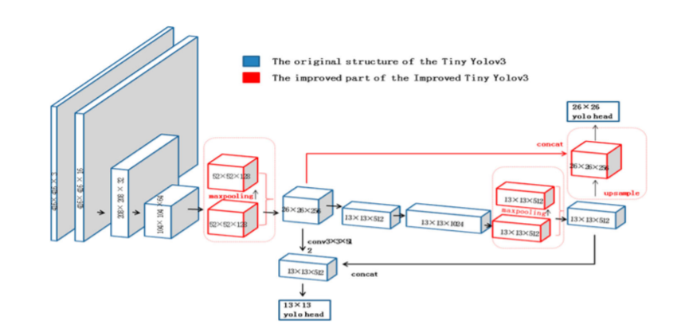

## Different network model size:

| Algorithm | Module size/M |
| --- | --- |
| YOLOv3 | 246.5 |
| Tiny YOLOv3 | 33.2 |
| Improved Tiny YOLOv3 | 55.9 |

## Detection speed of different algorithms:

| Algorithm | GPU (fps) | CPU (fps) |
| --- | --- | --- |
| Tiny YOLOv3 | 35.5 | 1.2 |
| Improved Tiny YOLOv3 | 32.5 | 1.1 |

## The average precision of the different classification:

| Algorithm | Class | Average precision (%) |
| --- | --- | --- |
| Tiny YOLOv3 | Set Screw | 90.76 |
| Tiny YOLOv3 | Nut | 32.18 |
| Improved Tiny YOLOv3 | Set Screw | 93.88 |
| Improved Tiny YOLOv3 | Nut | 97.24 |